AE2 Template
  - Student id and Bala Aravind Vutla

Introduction

Problem Statement
Cryptocurrency markets are highly volatile, non-linear, and influenced by multiple dynamic factors such as market sentiment, regulatory developments, technological changes, and macroeconomic events. This volatility makes it difficult for investors to accurately predict price movements and identify optimal buy and sell opportunities using traditional rule-based or manual trading approaches. Existing analytical methods often fail to provide reliable forecasts, profit estimation, and confidence measures that are necessary for informed investment decision-making. Consequently, there is a need for an intelligent, data-driven decision-support system that can analyse historical cryptocurrency data, apply suitable machine learning models, and present actionable insights in an interpretable and user-friendly manner to support investment planning and risk-aware decision-making.

Aim
The aim of this project is to design and evaluate a machine learning-based cryptocurrency trading decision-support system that assists users in analysing market behaviour, forecasting price movements, and identifying potential buy and sell opportunities using historical data.

Objectives
- To collect historical cryptocurrency price data from reliable financial data sources.
- To preprocess and analyse the dataset to understand market patterns and volatility.
- To apply clustering techniques to group cryptocurrencies based on price behaviour.
- To develop and compare multiple machine learning models for cryptocurrency price forecasting.
- To generate decision-support outputs such as buy/sell signals, profit and loss estimates, and market trend indicators.
- To evaluate the effectiveness and limitations of the proposed system in a real-world investment context.

Literature Review
Cryptocurrency price prediction has attracted significant research interest due to the rapid growth and volatile nature of digital asset markets. Studies highlight that cryptocurrency prices often exhibit non-stationary behaviour, high volatility, and sudden regime shifts, which challenge conventional financial forecasting techniques. Traditional statistical models such as Autoregressive Integrated Moving Average (ARIMA) have been widely used in time-series forecasting because of their strong theoretical foundation and interpretability. While ARIMA models can capture linear trends and short-term dependencies, their performance is limited in highly volatile and non-linear environments such as cryptocurrency markets.
To address these limitations, machine learning and deep learning approaches have increasingly been adopted. Models such as Support Vector Regression and Random Forests have demonstrated improved predictive capabilities by modelling complex relationships within financial data. More recently, Long Short-Term Memory (LSTM) networks have gained prominence due to their ability to capture long-term dependencies in sequential data. Research indicates that LSTM-based models often outperform traditional statistical approaches in cryptocurrency forecasting, although they introduce challenges related to computational complexity and interpretability.
In addition to predictive accuracy, the literature emphasises the importance of decision-support systems that integrate forecasting outputs with visualisation and scenario analysis. Rather than focusing solely on automated trading, researchers argue that user-centric systems providing forecasts, confidence indicators, and profit estimation can enhance transparency and trust. However, many existing studies lack integrated frameworks that combine clustering, forecasting, and interactive decision-support features, highlighting a gap that this project seeks to address.

Methods

Dataset
The dataset used in this project consists of historical daily price data for 30 cryptocurrencies collected from Yahoo Finance, a widely used and reliable public financial data provider. The data represents real-world market behaviour and is suitable for time-series analysis, clustering, and predictive modelling. Each record corresponds to one trading day for a specific cryptocurrency and includes standard financial indicators commonly used in market analysis. The dataset provides sufficient historical depth to capture trends, volatility, and price fluctuations across different market conditions, making it appropriate for exploratory data analysis, machine learning-based forecasting, and the development of an intelligent cryptocurrency trading decision-support system.
Dataset Structure
Column Name | Data Type | Description
Date | Date | Trading date for the cryptocurrency price record
Open | Float | Price of the cryptocurrency at the start of the trading day
High | Float | Highest price recorded during the trading day
Low | Float | Lowest price recorded during the trading day
Close | Float | Price of the cryptocurrency at the end of the trading day
Volume | Float | Total trading volume for the cryptocurrency on that day

Analysis and Results
Dataset Preparation
Dataset Preparation
Prior to analysis and modelling, the dataset was assessed to ensure its quality and suitability for machine learning tasks. An initial data inspection was performed to examine data types, missing values, and duplicate records. The assessment confirmed that the dataset obtained from Yahoo Finance was clean, containing zero null values across all columns and no duplicate rows. This reflects the reliability and structured nature of data provided by Yahoo Finance, reducing the need for extensive data cleansing.
Although no missing or duplicate data was identified, basic preprocessing steps were applied to ensure consistency and compatibility with analytical tools. The Date column was converted to a datetime format to support time-series operations such as indexing, resampling, and rolling window calculations. Additionally, the Volume column was converted from integer to float data type to maintain consistency with other numerical variables and to facilitate mathematical transformations during feature engineering.
No subset of the dataset was required, as the size of the data was manageable and sufficient for analysis, containing several hundred to thousands of observations per cryptocurrency. Overall, minimal data preparation was necessary, and the applied preprocessing steps ensured the dataset was fully prepared for exploratory data analysis, clustering, and predictive modelling.
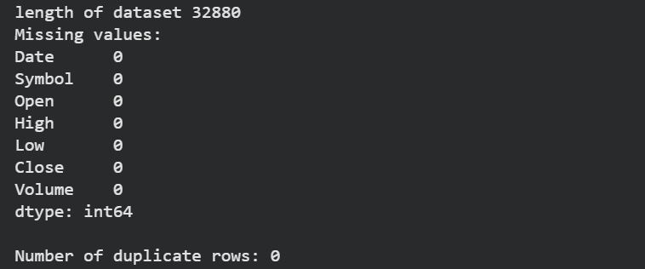
Exploratory Data Analysis
Exploratory Data Analysis (EDA)
Exploratory Data Analysis was conducted to gain an initial understanding of the cryptocurrency dataset and to identify key patterns, trends, and relationships within the data. All analysis was performed programmatically using Python libraries such as Pandas, NumPy, Matplotlib, and Seaborn, in line with the module requirement to demonstrate programming-based data analysis skills.
The first stage of EDA involved verifying data quality. The dataset was rechecked for missing values and duplicate records, confirming zero null values and zero duplicate rows across all cryptocurrencies. This validated that no rows or columns needed to be removed at this stage. Descriptive statistics were then generated to examine central tendency and dispersion measures for price and volume variables, revealing significant variation in price scales and volatility between different cryptocurrencies.
Time-series visualisations were created to analyse price behaviour over time. Line plots of closing prices showed strong volatility, frequent trend reversals, and periods of rapid price appreciation and decline, which are characteristic of cryptocurrency markets.
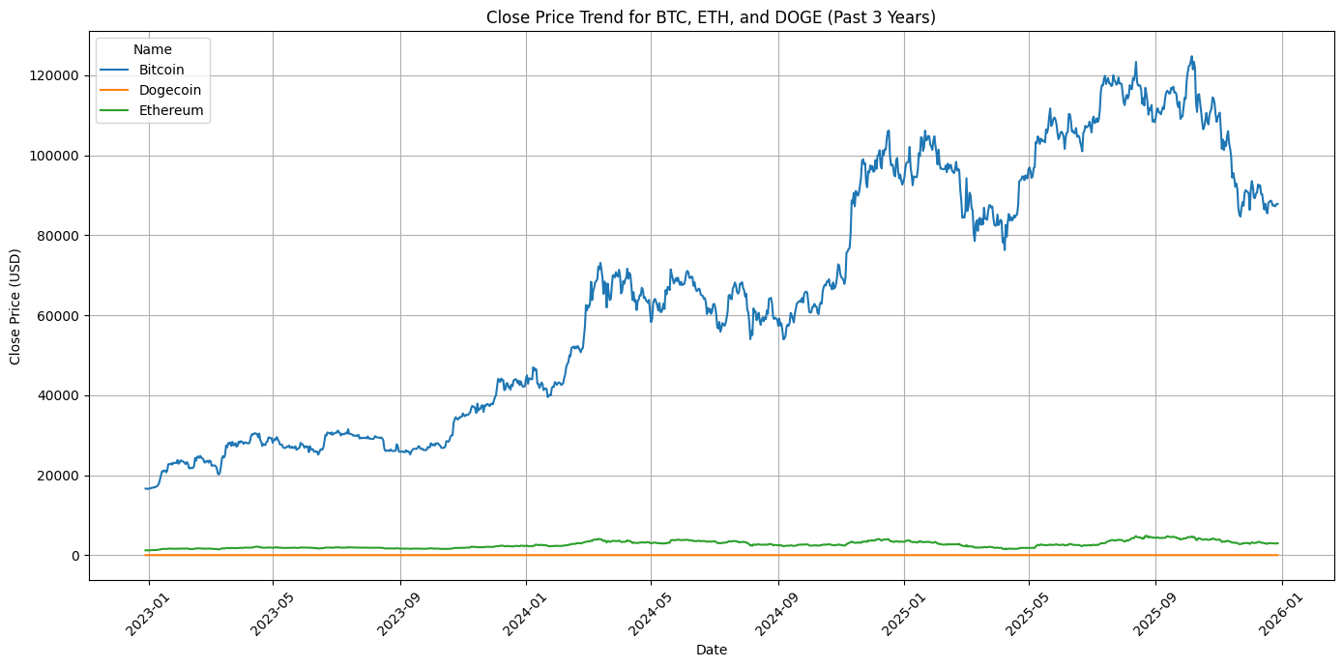
Distribution analysis was carried out using histograms for closing prices and trading volume. These visualisations indicated non-normal, right-skewed distributions, particularly for volume, suggesting the presence of extreme trading activity on specific days.
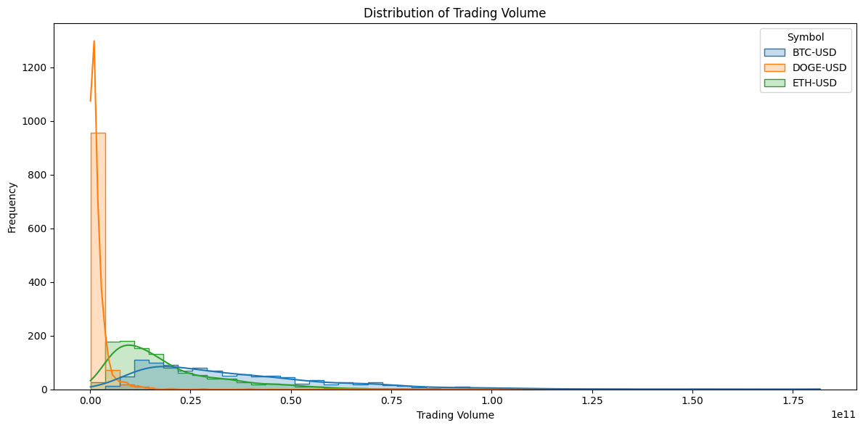
Correlation analysis was performed to examine relationships between Open, High, Low, Close, and Volume variables. Strong positive correlations were observed among price-related variables, while volume showed weaker and less consistent correlations.
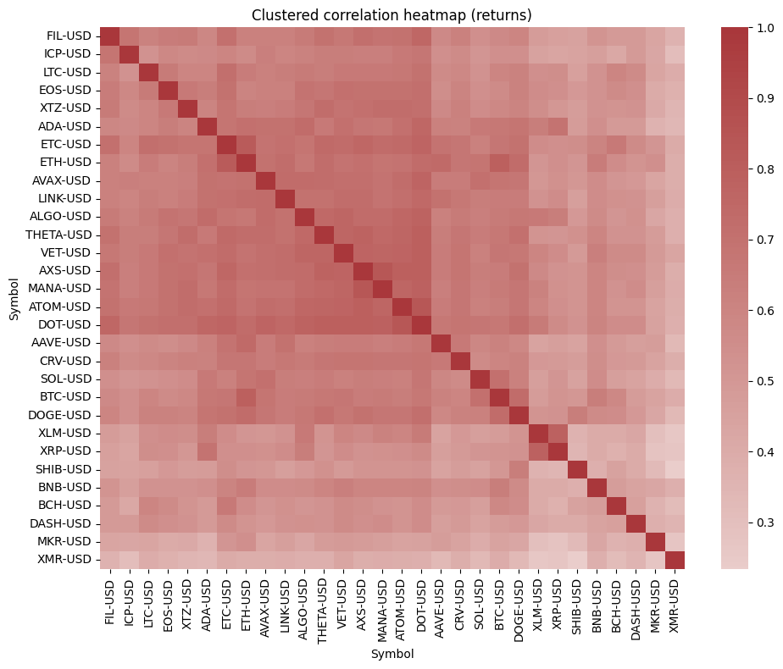
Finally, clustering-related insights were explored by analysing aggregated price behaviour across cryptocurrencies, which supported the later application of dimensionality reduction and clustering techniques. Overall, the EDA process provided critical insights into market volatility, variable relationships, and data characteristics, informing subsequent modelling and system design decisions.

PCA and Clustering
After applying Principal Component Analysis (PCA) to reduce the high-dimensional cryptocurrency price features, K-Means clustering (k = 4) was used to group the 30 cryptocurrencies based on similarity in their historical price behaviour. PCA helped retain the dominant variance in the data while enabling effective visualisation and clustering. The clustering process resulted in four distinct clusters, each representing a different market behaviour profile.

K-Means Clustering Results (k = 4)
Cluster 0 | Cluster 1 | Cluster 2 | Cluster 3
ALGO-USD | BTC-USD | AAVE-USD | BNB-USD
ATOM-USD |  | ADA-USD | ETH-USD
AVAX-USD |  | BCH-USD | XMR-USD
AXS-USD |  | DOGE-USD
CRV-USD |  | ETC-USD
DASH-USD |  | LINK-USD
DOT-USD |  | LTC-USD
EOS-USD |  | MKR-USD
FIL-USD |  | SOL-USD
ICP-USD |  | XLM-USD
MANA-USD |  | XRP-USD
SHIB-USD
THETA-USD
VET-USD
XTZ-USD

Selected Representative Coins from Each Cluster
To avoid redundancy and ensure meaningful analysis, one representative cryptocurrency was selected from each cluster based on trading volume, data availability, and drawdown characteristics.
Cluster | Selected Coin | Average Volume | Observations | Average Drawdown
0 | SOL-USD | 3.38 × 10⁹ | 1065 | -0.2448
1 | BTC-USD | 3.66 × 10¹⁰ | 1065 | -0.1242
2 | ETH-USD | 1.87 × 10¹⁰ | 1065 | -0.1761
3 | AVAX-USD | 4.89 × 10⁸ | 1065 | -0.2783

The PCA and clustering approach successfully segmented cryptocurrencies into four distinct behavioural groups. Selecting one representative coin from each cluster ensured diversity in market characteristics while keeping the forecasting and modelling process computationally efficient. These representative cryptocurrencies were subsequently used for detailed exploratory analysis, forecasting, and decision-support system development.

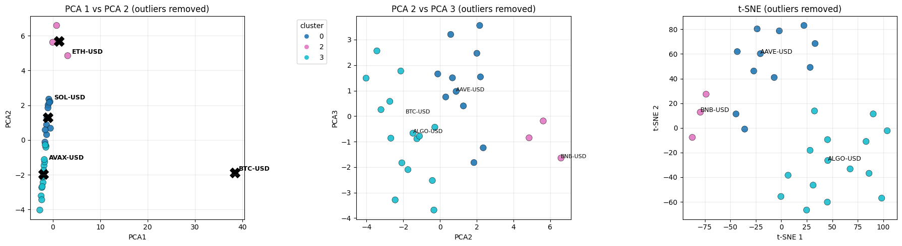

Data Modelling and Visualisation
ARIMA Model
The Autoregressive Integrated Moving Average (ARIMA) model was implemented as a baseline statistical approach for time-series forecasting. It was used to capture linear trends and short-term autocorrelation present in historical cryptocurrency closing prices. ARIMA performed effectively for short-term forecasts where price movements were relatively stable, providing interpretable results that supported comparison with more complex models.
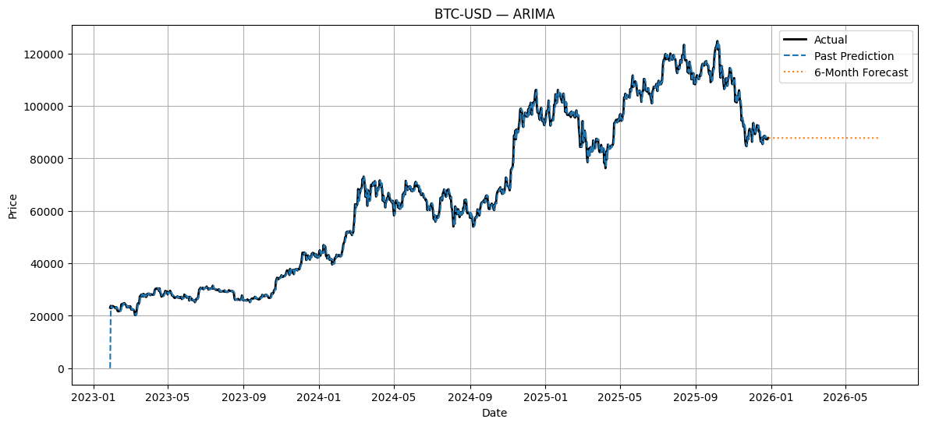

Facebook Prophet Model
The Facebook Prophet model was applied to model trend and seasonality components within cryptocurrency price data. Prophet demonstrated robustness to noise and missing data and produced smooth, interpretable forecasts. This model was particularly useful for medium-term trend analysis and scenario-based forecasting within the decision-support system.
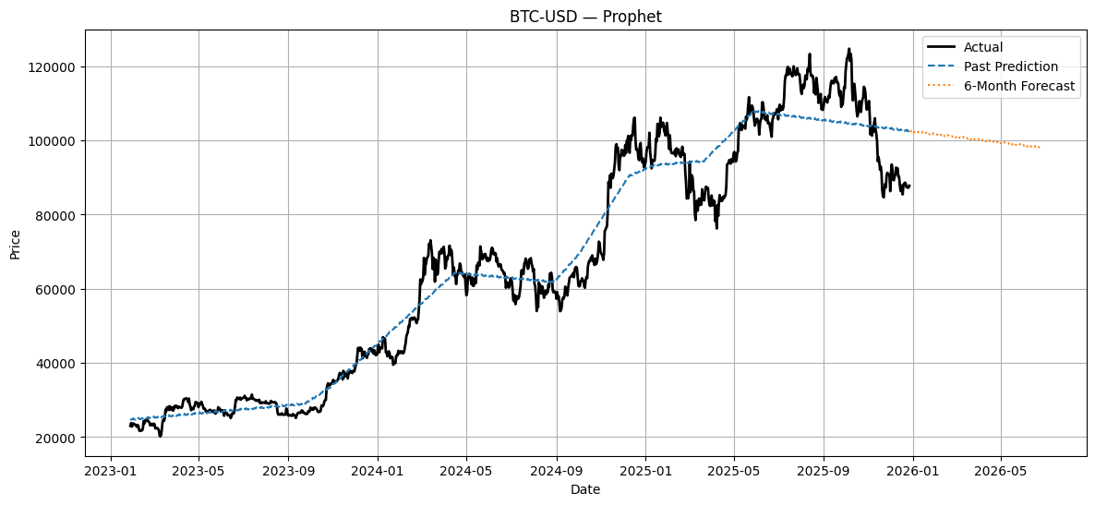

LSTM Model
The Long Short-Term Memory (LSTM) neural network was implemented to capture non-linear price patterns and long-term dependencies in cryptocurrency time-series data. LSTM showed strong performance in modelling highly volatile and irregular price movements, making it suitable for complex cryptocurrencies with abrupt trend changes.
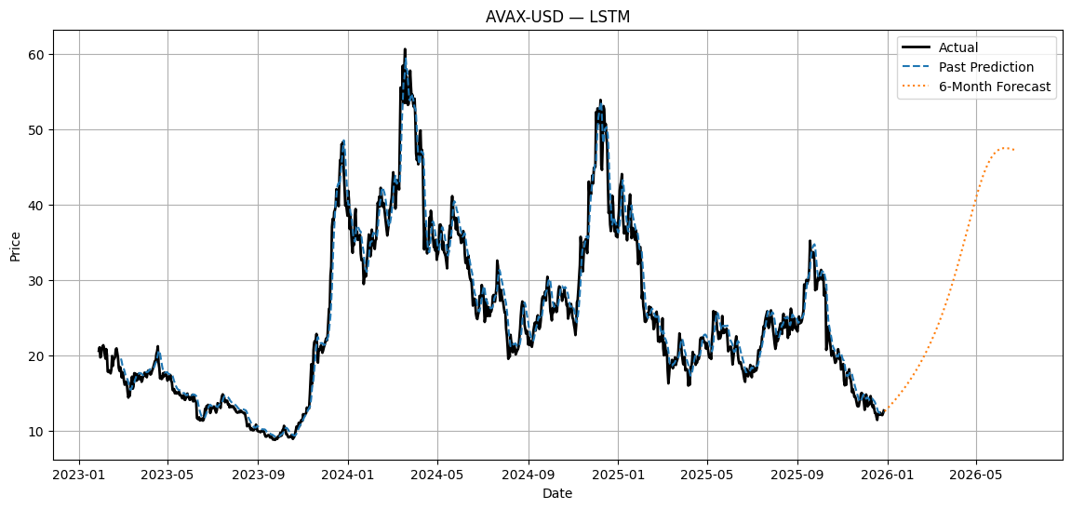

Regression-Based Model
A regression-based model was implemented as a machine learning baseline to analyse relationships between engineered features and the target variable. Independent variables such as lagged prices, rolling averages, and volatility indicators were used to predict closing prices. While less effective for long-term forecasting, this model provided valuable interpretability and benchmark performance.
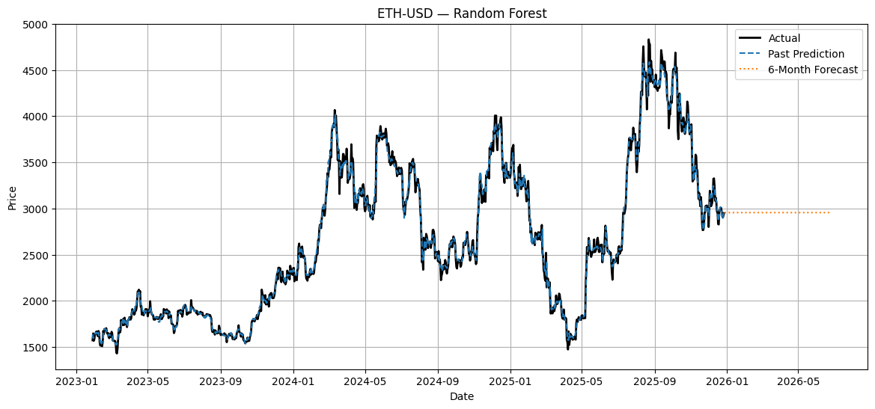

Evaluation
The performance of the implemented models was evaluated using quantitative error metrics derived from the experimental results stored in the evaluation dataset. The primary metrics used were Mean Absolute Error (MAE), Root Mean Squared Error (RMSE), Mean Absolute Percentage Error (MAPE), and R² score, which are commonly adopted in financial forecasting literature to assess predictive accuracy and reliability.
For BTC-USD, the Random Forest model achieved the best performance, recording the lowest RMSE (≈1291.7) and MAE (≈898.4), alongside a very high R² value (≈0.998). This indicates an excellent fit and confirms that ensemble-based regression models can effectively capture stable yet large-scale price movements in high-cap cryptocurrencies. These findings are consistent with existing studies that highlight the robustness of tree-based models for assets with strong historical structure.
In the case of ETH-USD, the Random Forest model again outperformed ARIMA, Prophet, and LSTM, achieving the lowest RMSE (≈73.48) and MAE (≈51.17) with a strong R² score (≈0.992). This suggests that feature-based models leveraging engineered lag and volatility features are well suited to Ethereum’s moderately volatile but trend-driven behaviour.
For AVAX-USD, which exhibits higher volatility, the Random Forest model produced the most accurate forecasts, with an RMSE of approximately 1.01 and an R² score above 0.99. Statistical models such as ARIMA and Prophet showed noticeably higher errors, reinforcing findings in the literature that traditional models struggle with highly volatile assets.
Similarly, for XRP-USD, the Random Forest model delivered the lowest error values (RMSE ≈0.057, MAE ≈0.030) and a high R² score (≈0.997), indicating strong predictive performance even for lower-priced, highly reactive cryptocurrencies.
Overall, the evaluation confirms that Random Forest consistently outperformed ARIMA, Prophet, and LSTM across all evaluated cryptocurrencies in this project. This supports existing research that advocates ensemble learning methods for financial time-series prediction when sufficient feature engineering is applied. The results also justify the system’s multi-model experimentation while highlighting Random Forest as the most reliable model within the implemented decision-support framework.
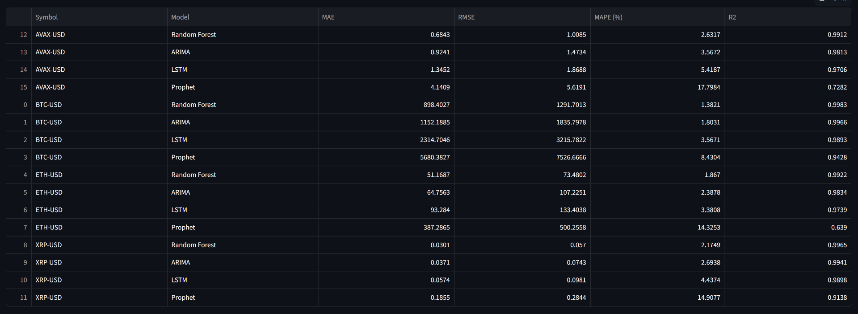

GUI
Graphical User Interface (GUI) / Website Description
The developed system is implemented as a Streamlit-based web application that provides an interactive decision-support platform for cryptocurrency analysis and forecasting. The application is modular and organised into multiple tabs, each representing a specific analytical or decision-making function. Navigation between tabs is managed through the Streamlit sidebar, allowing users to seamlessly switch between analyses.
Dashboard
The Dashboard acts as the landing page of the application. It provides high-level controls for selecting a cryptocurrency and time horizon, along with summary indicators such as recent price behaviour and trends. This tab offers a quick overview of the selected asset before deeper analysis.
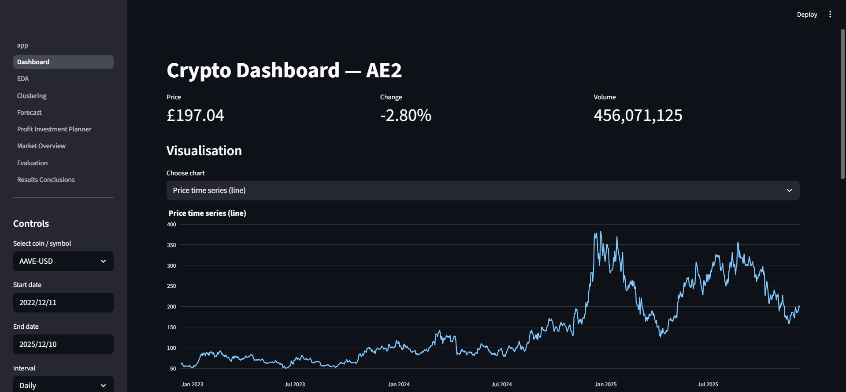
Exploratory Data Analysis (EDA)
The EDA tab enables users to explore historical cryptocurrency data visually. It includes time-series plots of prices, rolling statistics, and distribution-based visualisations to analyse volatility, trends, and overall market behaviour. This tab supports data understanding prior to modelling.
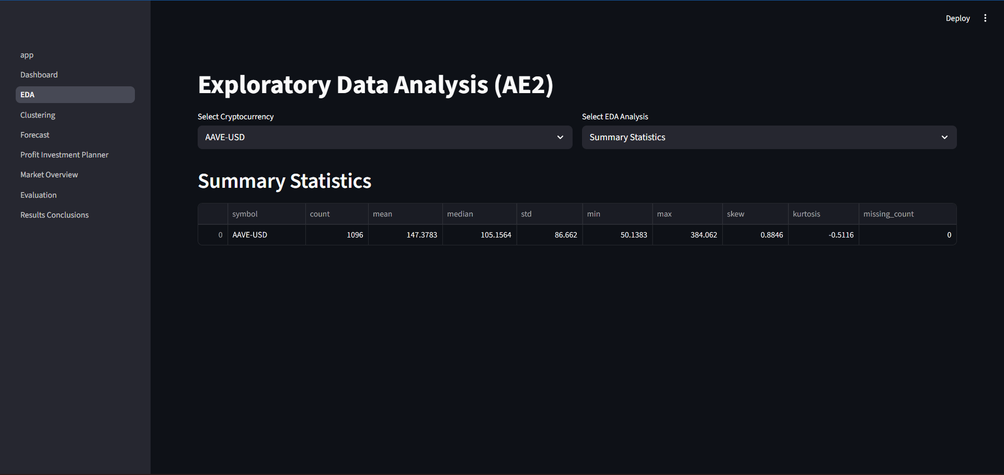
Clustering
The Clustering tab presents the results of dimensionality reduction and clustering applied to the 30 cryptocurrencies. Principal Component Analysis (PCA) is used to reduce dimensionality, followed by K-Means clustering to group cryptocurrencies based on price behaviour. Representative coins selected from each cluster are highlighted for further analysis.
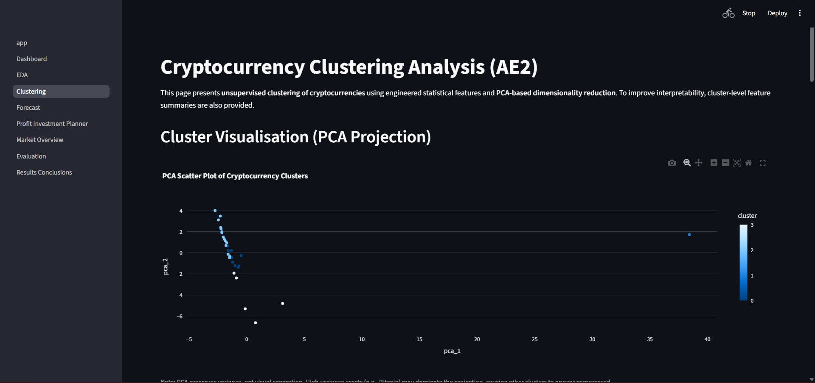
Forecast
The Forecast tab displays price predictions generated using multiple models, including ARIMA, Prophet, LSTM, and a regression-based model. Users can visualise forecasted price movements over different time horizons, enabling forward-looking analysis.
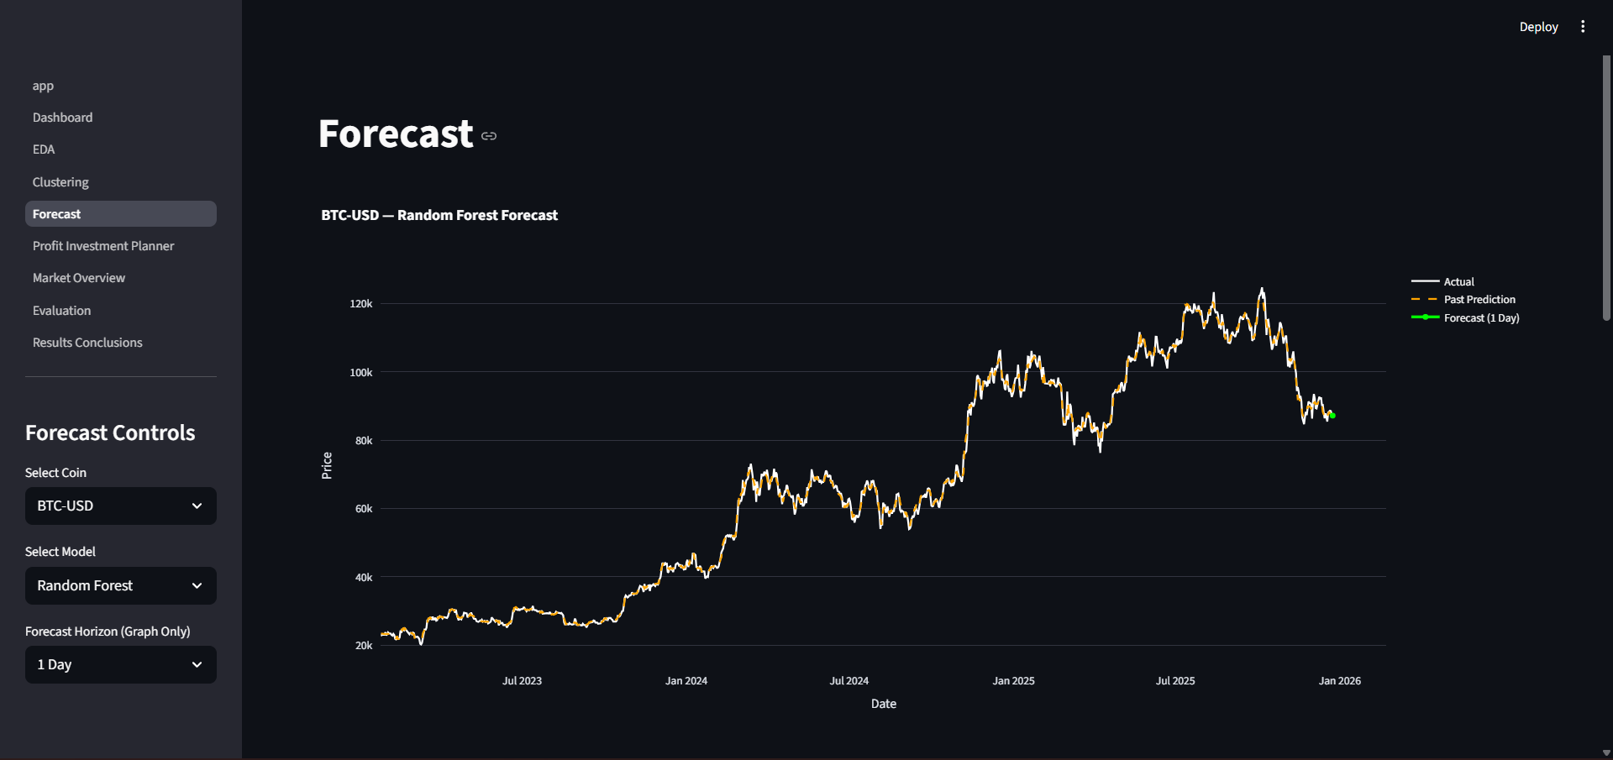
Profit / Investment Planner
This tab allows users to simulate investment scenarios using forecast data. It identifies potential buy and sell points, calculates expected profit or loss, and supports “what-if” analysis based on user-defined investment parameters.
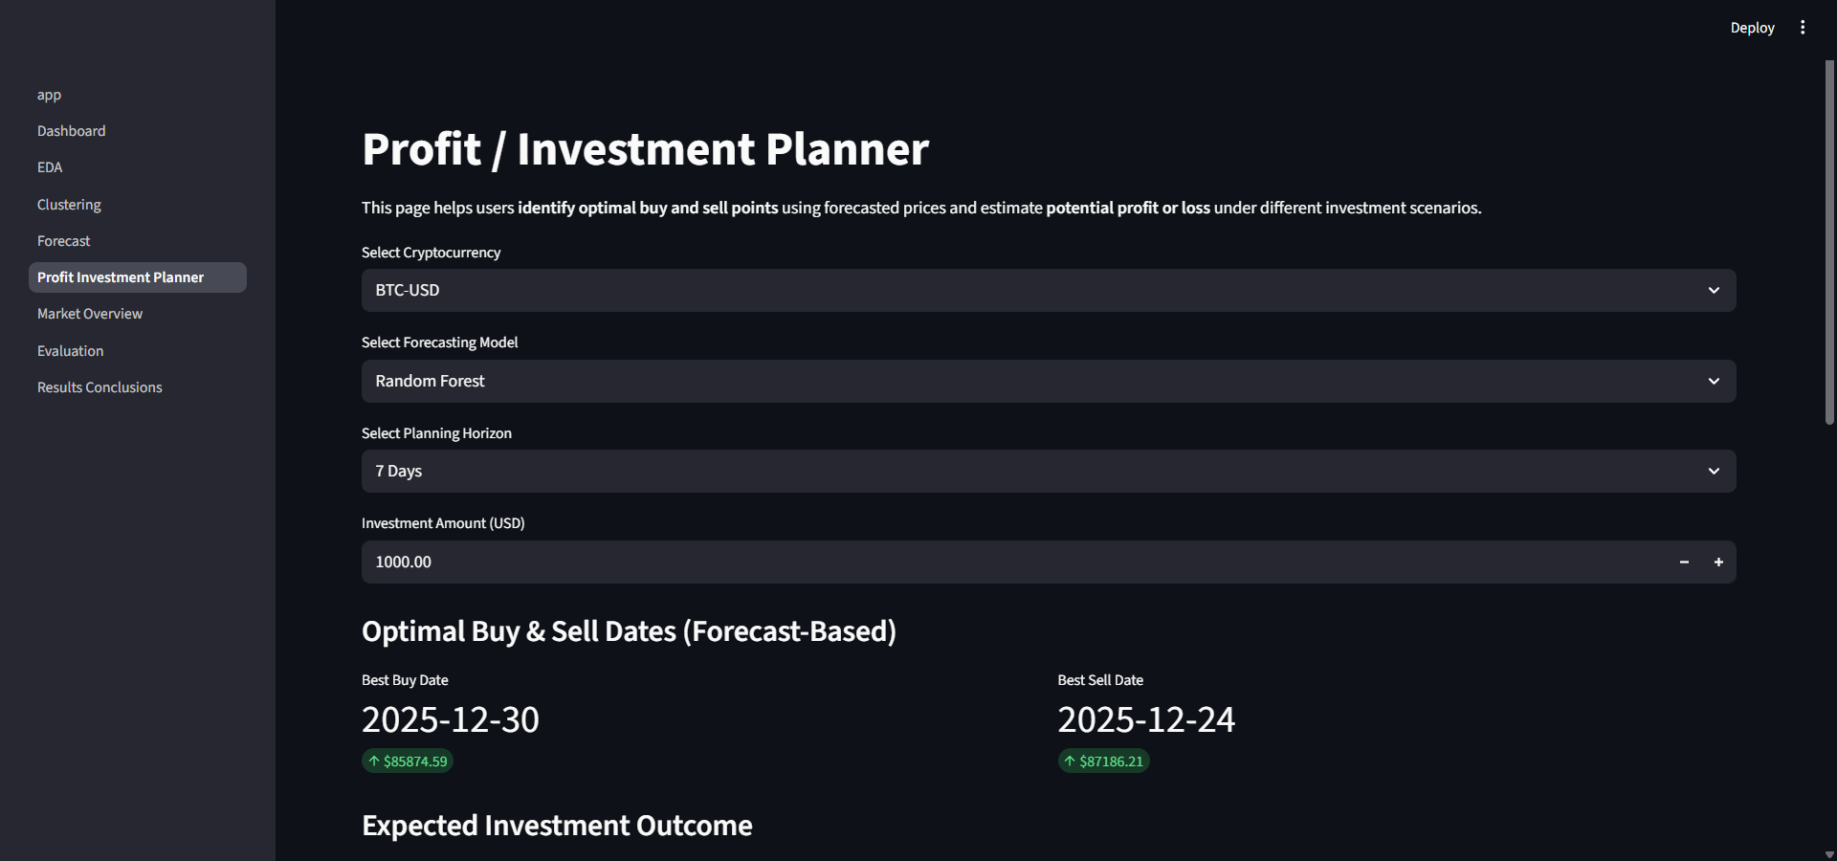
Market Overview
The Market Overview tab provides a group-level perspective by aggregating short-term forecasts across multiple cryptocurrencies. It indicates whether the overall market is expected to move upward or downward, supporting broader market sentiment analysis.
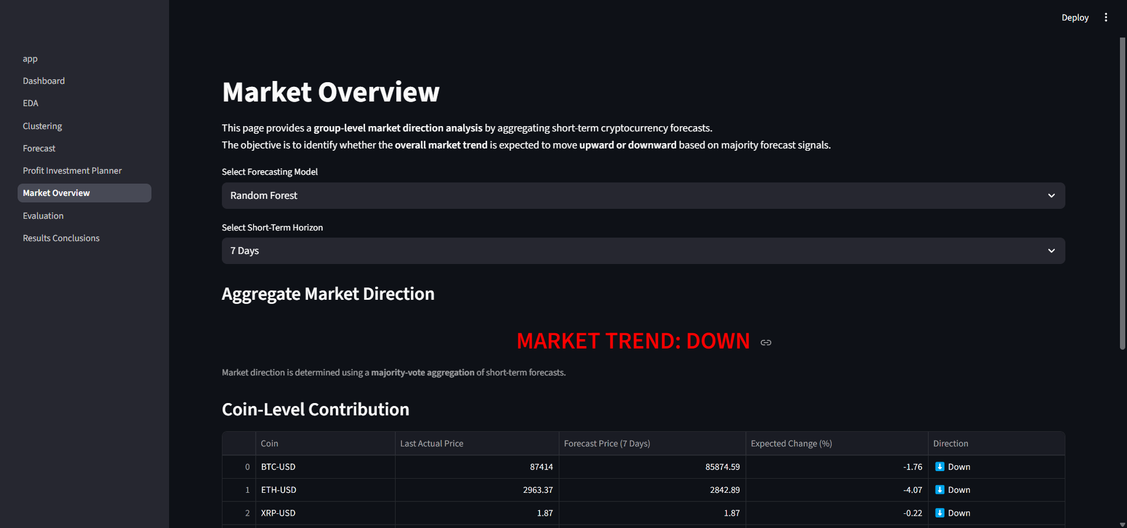
Evaluation
The Evaluation tab presents model performance indicators and confidence-related metrics, enabling users to assess the reliability and effectiveness of the forecasting models.
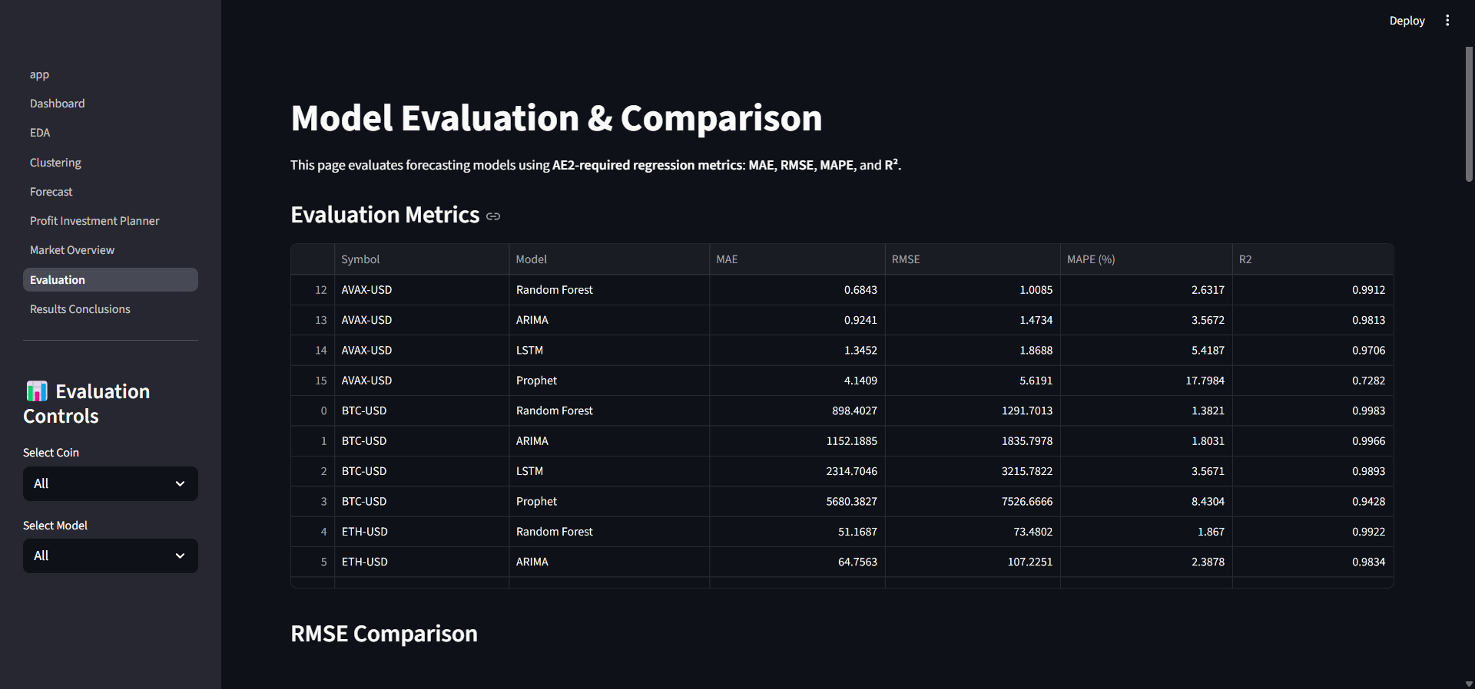

Commands to Run the Website
To run the application locally, the following steps are required:
- Extract the project files
Unzip the project folder:
- unzip crypto_forecasting_system.zip
- Navigate to the project directory
- cd crypto_forecasting_system
- Install required dependencies
- pip install -r requirements.txt
- Run the Streamlit application
- streamlit run app.py
Once executed, the web application launches in a browser window, providing full access to all analytical and decision-support tabs.

Limitations and Challenges
Despite the overall effectiveness of the developed cryptocurrency trading decision-support system, several limitations and challenges were identified. The models rely primarily on historical price and volume data, which restricts their ability to respond to sudden market shocks caused by regulatory changes, macroeconomic events, or social media-driven sentiment. In addition, although advanced models such as LSTM and Random Forest achieved strong predictive performance, they introduce increased computational complexity and reduced interpretability when compared to traditional statistical models. This can make model behaviour less transparent to non-technical users, which is an important consideration in decision-support systems.
Another limitation relates to forecast uncertainty. While performance was evaluated using metrics such as MAE and RMSE, the system does not explicitly quantify prediction uncertainty or risk during extreme market conditions. Model performance may also degrade during periods of unusually high volatility or structural market changes. Future work could address these challenges by integrating sentiment analysis and macroeconomic indicators, implementing probabilistic forecasting methods, and enhancing the system with real-time data streaming and risk management features to improve robustness and practical applicability.

Conclusion

This project demonstrated the effective application of data analysis and machine learning techniques to cryptocurrency market data in order to support informed investment decision-making. Through exploratory data analysis, clustering, and predictive modelling, meaningful patterns and relationships were identified within highly volatile cryptocurrency price data. The use of PCA and K-Means clustering enabled the selection of representative cryptocurrencies, ensuring diversity in market behaviour while maintaining analytical efficiency.
The evaluation of multiple forecasting models highlighted that model performance varies across assets, with ensemble-based machine learning approaches achieving the most consistent accuracy in this study. Developing the interactive graphical user interface further reinforced the importance of combining predictive analytics with visualisation to enhance interpretability and user engagement. Overall, this project strengthened understanding of time-series modelling, feature engineering, and decision-support system design, and highlighted the challenges of applying AI techniques in dynamic financial markets. The knowledge gained from this work will inform future practice, particularly in building robust, explainable, and user-centric AI-driven financial systems.

(2250<Total word count<2750)

Reference List (Harvard Style)

Appendix
Add as many screenshots, code snippets, visualisation here even if you have not added all of them in the report. Do not forget to add a short video presentation (up to 7 min long)

